PCB DESIGN & MANUFACTURING DOCUMENT

RC CAR CONTROL SYSTEM PCB

1. Scope & Objective

1.1 Scope
The scope of this project is to design and manufacture a compact, reliable, and manufacturable PCB for an RC (Remote Controlled) Car, capable of:
- Receiving wireless control signals
- Driving DC motors for propulsion
- Controlling a servo motor for steering
- Managing battery power safely and efficiently
The PCB integrates control, power, and communication subsystems on a single board.

1.2 Objective
- Design a 2-layer PCB suitable for low-cost manufacturing
- Support high-current motor paths without overheating
- Ensure stable MCU and RF operation in a noisy motor environment
- Follow industry-standard PCB design rules
- Generate production-ready fabrication and assembly files

2. System Schematic Design

2.1 Functional Blocks
- Power Input & Protection
- Voltage Regulation
- Microcontroller Unit (MCU)
- Motor Driver Circuit
- Servo Interface
- Wireless Communication Module
- Programming & Debug Interface
- 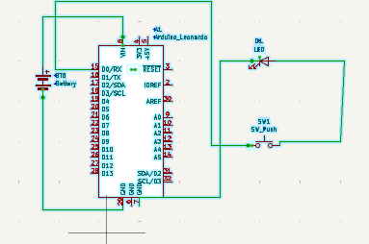

2.2 Schematic Description

Power Section
- Battery Input: 7.4V Li-ion/LiPo
- Reverse polarity protection (P-channel MOSFET / diode)
- Bulk capacitor (470µF–1000µF) near battery
- Buck converter: 7.4V → 5V
- LDO: 5V → 3.3V (RF module)
Important Point:
Motor power and logic power must be filtered and decoupled separately.

MCU Section
- Example MCU: ATmega328P / STM32 / ESP32
- Decoupling capacitors (0.1µF) near each VCC pin
- Reset pull-up resistor (10kΩ)
- Programming header (ISP / SWD / UART)

Motor Driver Section
- Dual H-Bridge motor driver (TB6612FNG / L298)
- Flyback diodes (if required)
- PWM control from MCU
- High-current motor connectors
Important Point:
Motor driver ground should connect to system ground at a single star point.

Servo Control
- Standard 3-pin servo header (VCC, GND, PWM)
- Separate power trace from logic supply

RF Communication
- Module: nRF24L01 / HC-12 / ESP32
- 3.3V regulated supply
- SPI/UART communication
- Antenna clearance area

3. PCB Layout – Placement & Routing

3.1 Component Placement
Area | Placement Rule
MCU | Center of board
Motor Driver | Near motor connectors
Buck Converter | Near battery input
RF Module | At PCB edge
Programming Header | Board edge
Important Points:
- Keep RF module away from motor driver
- Short, direct paths for high-current components
- Place decoupling capacitors as close as possible to IC pins

3.2 Routing Guidelines

Signal Routing
- Use short traces for clock and RF signals
- Avoid routing signal traces under motor driver
- Maintain 45° trace angles

Power Routing
- Motor traces ≥ 80–120 mil (depending on current)
- Use copper pours for power and ground
- Bottom layer: solid ground plane
Important Point:
Never route motor current under MCU or RF module.
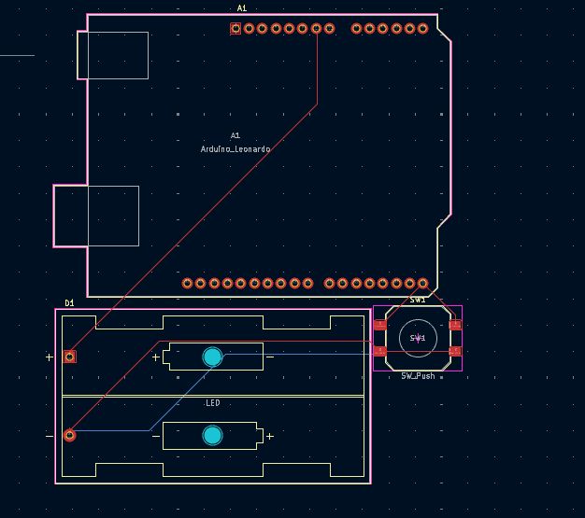

4. Footprint Assignment & PCB Design Rules (DRC)

4.1 Footprint Assignment
- All footprints must match manufacturer datasheets
- Use through-hole connectors for motors and battery
- Use SMD components for compact layout

4.2 PCB Design Rules (Typical)
Parameter | Value
Min Track Width | 6 mil
Min Clearance | 6 mil
Via Drill | ≥ 0.3 mm
Via Diameter | ≥ 0.6 mm
Annular Ring | ≥ 0.15 mm
Copper Thickness | 1 oz (2 oz recommended)
Board Thickness | 1.6 mm
Important Point:
DRC must pass with zero errors before fabrication.

5. 2D / 3D PCB Views & Final Checks

5.1 2D PCB View
- Verify silkscreen readability
- Check reference designators
- Confirm polarity markings

5.2 3D PCB View
- Validate connector orientation
- Ensure no mechanical interference
- Check component heights

5.3 Final Design Checks
- ERC (Electrical Rule Check) passed
- DRC passed
- Power net continuity verified
- No floating pins
- Correct net naming
- Thermal reliefs on large copper areas
- 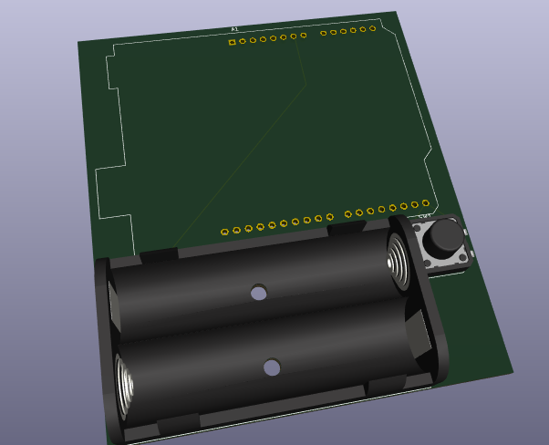
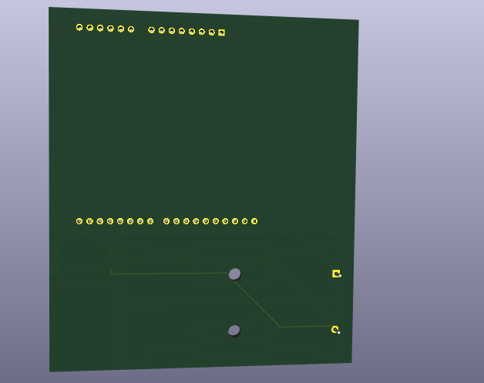

6. Production Files (Fabrication & Assembly)

6.1 Fabrication Files
- Gerber files (Top, Bottom, Mask, Silkscreen)
- Drill files (Excellon)
- Board outline
- Fabrication drawing (PDF)

6.2 Assembly Files
- Pick & Place file
- Assembly drawing (Top/Bottom)
- BOM with manufacturer part numbers

7. Bill of Materials (BOM – Example)
Item | Component | Value | Package | Importance
MCU | ATmega328P | — | TQFP-32 | Control
Motor Driver | TB6612FNG | — | SOP-16 | Drive
Buck Regulator | LM2596 | — | D2PAK | Power
RF Module | nRF24L01 | — | Module | Communication
Capacitors | Ceramic | 0.1µF | 0603 | Decoupling
Electrolytic | Capacitor | 470µF | TH | Filtering
Resistors | Pull-ups | 10kΩ | 0603 | Stability
Battery Conn | XT30 | — | TH | Power
Motor Conn | Screw Terminal | — | TH | Output

8. Important Design Considerations (Summary)
- Separate motor and logic grounds
- Use wide traces for high current
- Maintain RF clearance
- Add power protection
- Follow manufacturer footprint guidelines
- Always run ERC & DRC before fabrication

